



[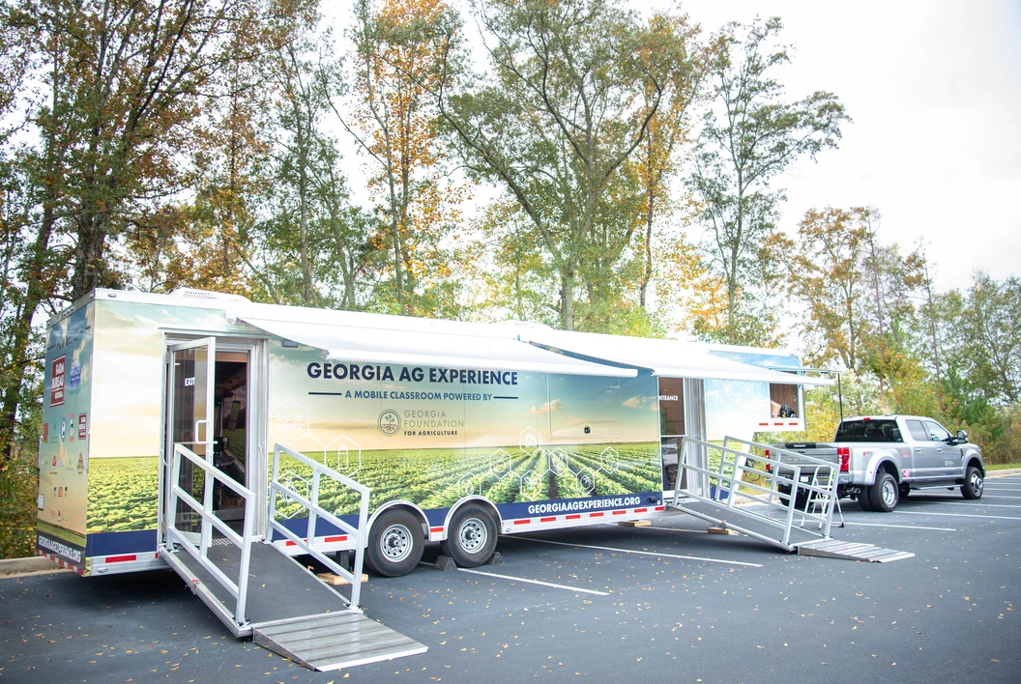](https://www.gafoundationag.org/georgia-ag-experience)

[](http://www.gafoundationag.org/JoinUs.html)[](https://www.facebook.com/GAfoundationAg)[](https://www.instagram.com/gafoundationag/)

[](https://www.georgiaagexperience.org/partners/sponsors.cms)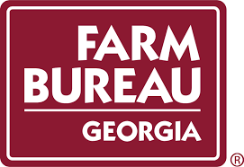****

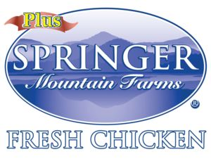









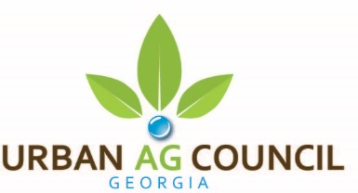

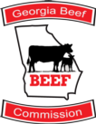



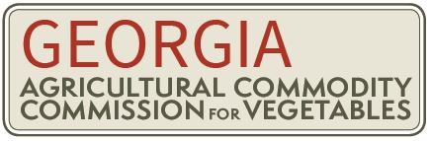

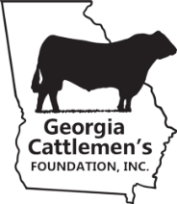



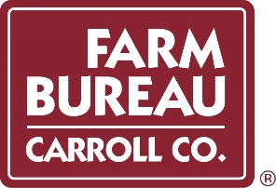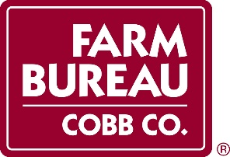



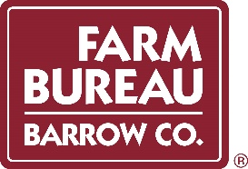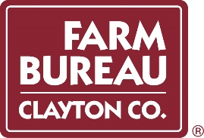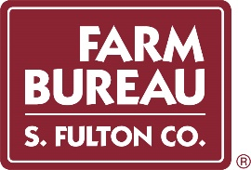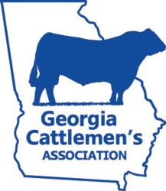

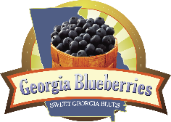

[Agricultural Commodity Commission for Peaches](https://gapeaches.org/) - [Buck Jones Nursery](https://www.buckjones.com/) - [Color Burst](https://www.color-burst.com/) - [Landscapes of the South, Inc.](http://www.landscapesofthesouth.com/) - [Monrovia](https://www.monrovia.com/) - Jeff Davis County Farm Bureau Jones County Farm Bureau - Newton County Farm Bureau - Ruppert Landscape - Thomas Trees & Plants, Inc. - Cleveland Tree Company Banks County Farm Bureau - Brooks County Farm Bureau - Clayton County Farm Bureau - Colquitt County Farm Bureau - Decatur County Farm Bureau Dougherty County Farm Bureau - Elbert County Farm Bureau - Franklin County Farm Bureau - Grady County Farm Bureau - Habersham County Farm Bureau Hall County Farm Bureau - Hart County Farm Bureau - Houston County Farm Bureau - Jefferson County Farm Bureau - Johnson County Farm Bureau Madison County Farm Bureau - Mitchell County Farm Bureau - Oglethorpe County Farm Bureau -Stephens County Farm Bureau -Thomas County Farm Bureau Tift County Farm Bureau - Towns County Farm Bureau - Twiggs County - Wheeler County. Farm Bureau - White County Farm Bureau - Worth County Farm Bureau

**The Georgia Ag Experience is provided by The Georgia Foundation for Agriculture. Our mission is to prepare the next generation of Georgia leaders for success in agriculture. Learn about our programs by visiting our** [**website.**](https://www.gafoundationag.org/)

**Thank you to our wonderful sponsors!**

1. **Welcome Letter**
2. **Overview**
3. **Get to Know the GAE Program Assistants**
4. **Step 1: Pre-Visit & Post-Visit Survey (Required)**
5. **Step 2: Pre-Visit Lesson (Required)**
6. **Step 3: Post-Visit Lesson (Required)**

**WHAT IS INCLUDED IN THE PACKET?**

WELCOME LETTER

On behalf of the Georgia Foundation for Agriculture, it is with great pleasure that we welcome you to the Georgia Ag. Experience Program. We have high expectations of what the students will learn, and we strive to inspire all children to develop an appreciation of agriculture through our creative STEM based curriculum. This unique program will have your students engaged before our visit, during our visit and after our visit.

We have created a packet to help you understand what is needed to ensure a successful and impactful interaction with the Georgia Ag. Experience. There is a lot of information, so make sure you take some time to go through it. One of the exciting items you will find in the packet is engaging lesson plans specifically created for the Georgia Ag. Experience. The pre-visit and post-visit lesson will enhance and continue the learning process for your students.

Our mission with the Georgia Ag. Experience is simple, we want to inspire the next generation of Georgia’s agricultural leaders. This experience will provide an overview to all students of Georgia’s largest industry, agriculture, and the importance of supporting the 42,000 plus farmers in our state. We appreciate you inviting us to your school and helping us achieve our mission. We are very excited to share our state-of-the-art mobile classroom with you. We look forward to being at your school soon and we know that your students and teachers will be amazed by what they learn!

With Appreciation,



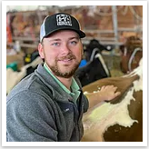

**LILY BAUCOM**

*Executive Director*

Georgia Foundation For Agriculture

**LAUREN GOBLE Taylor Casper Jay Moon**

*Educational Programs Coordinator GAE Programs Assistant GAE Programs Assistant*

Georgia Farm Bureau Georgia Foundation For Agriculture Georgia Foundation For Agriculture

[**WWW.GEORGIAAGEXPERIENCE.ORG**](http://WWW.GEORGIAAGEXPERIENCE.ORG/)

[](https://www.gafoundationag.org/georgia-ag-experience)

**PRE-VISIT LESSON**

**PRE-VISIT LESSON**

**OVERVIEW**

In this packet, you will find the **required** pre and post visit lessons that were created specifically for the Georgia Ag Experience. Please utilize, modify, and implement as you see fit for your students’ needs and your time constraints. Making an effective lesson plan takes time, diligence, and an understanding of your students' goals and abilities. The goal, as with all teaching, is to motivate the students to take in what you are teaching and to retain as much as possible. With that in mind, thank you for working with the Georgia Ag Experience and thank you for all that you do as a teacher. We want to know your professional opinion of these lessons. Please contact us at[**info@georgiaagexperience.org**.](mailto:info@georgiaagexperience.org)

What is the Georgia AG Experience?

The Georgia Ag Experience is a unique STEM based educational program that invites 3rd-5th grade students across Georgia to explore the vast opportunities in agriculture. Our 36-foot mobile classroom showcases Georgia Agriculture on-the-road. We visit Georgia elementary schools and community organizations, targeting students in grades 3 through 5. The Georgia Ag Experience uses technology and digital learning so students can take a deep-dive into different agricultural commodities.

We want to help students:

* Gain a better understanding and become an advocate of agriculture
* Learn about technology and the future of farming
* Recognize their role and identify future career opportunities

The full program involves:

* *1 educational lesson prior to the experience (required) - 1 hour in-person experience with hands on activities with GAE assistant*
* *1 educational lesson after the experience (required) - Optional participation in bi-annual a real-world GEA STEM challenge*

Curriculum was developed in part by professors at The University of Georgia in the College of Agricultural and Environmental Sciences and the Georgia Ag Experience Team. The lesson plans meet [Georgia educational standards](https://georgiaagexperience.org/skins/userfiles/files/Georgia%20State%20Standards%20pdf.pdf)  as well as elementary agricultural education standards and incorporate STEM teaching practices. They will be updated periodically to keep pace with educational requirements and agricultural advancements. Our goal is to increase students’ knowledge of and attitude toward Georgia agriculture.

Pre-Visit - Completed by Participating School / Classroom Instructor

Prior to the visit, students learn the basics of Georgia agriculture so that they are prepared for the mobile classroom visit and are ready to maximize their learning experience. We provide a simple lesson plan tailored to each grade level based on grade level standards and require schools to utilize the plans so that all students have the same understanding.

-Pre-Visit Survey prior to Georgia Ag Experience.

-Pre-Visit Lesson prior to Georgia Ag Experience. Lessons are grade specific but may be utilized to your own classes needs.

-Standards Covered are linked [here](https://georgiaagexperience.org/skins/userfiles/files/Georgia%20State%20Standards%20pdf.pdf).

During Visit - Completed by GAE Classroom Educator

At the beginning of the 1-hour block, the class (no larger than 30 students) will be split into 2 groups, depending on the number of students and participate in the following sessions:

* 10 Minutes: Welcome and Introductory AGtivity with Education Program Assistants (inside depending on weather)
* 20 Minutes: Mobile Classroom
  + Click here for a mobile tour and list of the 8 stations.
* 20 Minutes: Outside AGtivity with Farm Bureau volunteers or teachers (inside depending on weather)

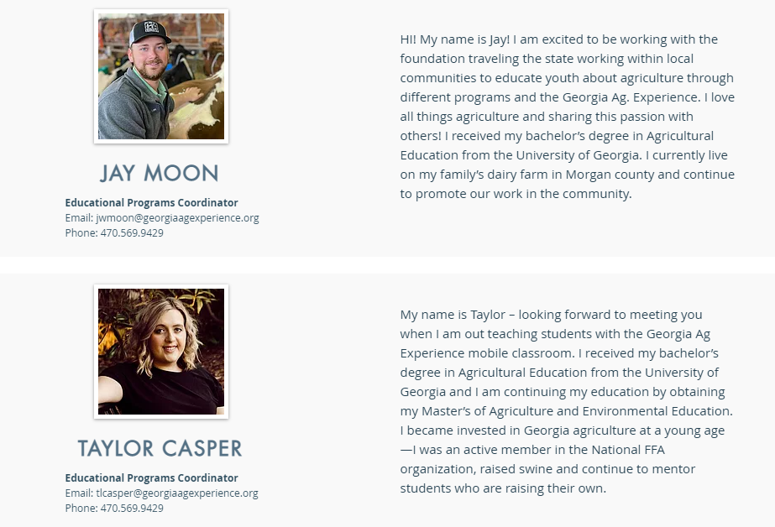

**Educational Programs Coordinator**

Email: jwmoon@georgiaagexperience.org

Phone: 706.818.1873

***We are both excited to be working collaboratively with your school as well as meet you and your students!***

**GET TO KNOW THE GAE PROGRAM ASSISTANTS**



**PRE-VISIT SURVEY &**

**POST VISIT SURVEY**



Pre-Visit Survey:

The first step in preparing for the Georgia Ag Experience to arrive is completing the pre-visit survey that we have designed to assess student’s prior knowledge and understanding of agriculture. It is comparable to the idea of a pre-test when in a classroom.

It is a **REQUIRED** part of our Georgia Ag Experience and can assist our team in furthering curriculum and ensures the future of the mobile classroom. We ask that you begin this survey the day before you begin your pre-visit lesson.

Students are **not** expected to know the answers to these questions; this is the cognitive pre-test that helps up study the impact of the Georgia Ag Experience program.

Have students take the online ***pre-visit assessment*** by visiting: [www.gfb.ag/GAEprevisitsurvey](http://www.gfb.ag/GAEprevisitsurvey).

Post Visit Survey:

After the Georgia Ag Experience has been to your school, we hope that it ignites interest about agriculture in

your students!

In order to continue their agriculture education experience, we ask that you complete the following:

1. Post Visit Survey **(Required)**
2. Post Visit Lesson Plan **(Required)**

The post visit survey is a short survey, similarly to the pre-visit survey, it assists with Georgia Ag Experience data collection. The *Post-Visit Ag. Knowledge/Attitude Assessment & Experience* *[Survey](http://www.gfb.ag/GAEstudentpost)*can be accessed by following this link: **http://www.gfb.ag/GAEstudentpost**

Also, to continue student’s agriculture education experience, we ask that you complete the post visit lesson plan and checkout our website for further resources!

**PRE-VISIT LESSON OVERVIEW**

|  |  |  |
| --- | --- | --- |
| **Lessons Overview:** | **Pre-Visit General Georgia Agriculture** | |
| **Estimated Time:** | 1 – 2, 50 Minute Classes | |
| **Grade Level:** | 3RD - 5TH | |
| **Materials, References, and Other Resources:** | | |
| **Interest Approach Websites, Resources, & Worksheets**   1. Pre-Visit Knowledge Assessment: [www.gfb.ag/GAEprevisitsurvey](http://www.gfb.ag/GAEprevisitsurvey) 2. Apple (Other items such as milk, blueberries, eggs, agricultural products etc. can be used) Refer to lesson for more details. 3. Certified Farm Market: www.gfb.ag/CertifiedFarmMarket   **3rd Grade Lesson Websites, Resources, & Worksheets**   1. [Georgia Agriculture Video](https://www.youtube.com/watch?v=TclVUemhBgs) 2. [Georgia Agricultural Map](https://georgiaagexperience.org/skins/userfiles/files/Georgia%20Agricultural%20Products%20Map.pdf) 3. [Georgia Ag Facts](https://georgiaagexperience.org/skins/userfiles/files/A%20Look%20at%20Georgia%20Agriculture.pdf) 4. USDA Agricultural Census website at: [www.gfb.ag/agcountyinfo](http://www.gfb.ag/agcountyinfo) 5. AgSnapshots: [www.gfb.ag/agsnapshots](http://www.gfb.ag/agsnapshots) 6. <https://georgiadata.org/topics/agriculture/farm-gate-value>   **4th Grade Lesson Websites, Resources, & Worksheets**   1. Ball of Yarn 2. Food Web Activity Sheets 3. Tape 4. [Food Web Video](https://www.youtube.com/watch?v=pasB5FxhVUk)   **5th Grade Lesson Websites, Resources, & Worksheets**   1. Butcher Paper 2. Large Markers 3. [Supply Chain Video](https://www.youtube.com/watch?v=v7HNTGXwQd0)   **Other Resources:**   - Blank Map of Georgia (link)    - [Agricultural Product Fact Sheets](https://georgiaagexperience.org/skins/userfiles/files/Agricultural%20Product%20Fact%20Sheets.pdf): Pecan, Fruit, Vegetable, Dairy, Beef, Peanuts, Cotton, Horticulture, Forestry, Poultry    - [Career Exploration Worksheet (link)](https://georgiaagexperience.org/skins/userfiles/files/Career%20Exploration%20Worksheet.pdf) | | |
| **Vocabulary Words & Ag Facts** | | |
| ***agriculture***: the science and process of growing plants for food and raising animals for items we use in our everyday life  ***agricultural products:*** an animal or plant including any food or drink that comes from an animal or plant  ***career***: a job for which one prepares for and which is undertaken as a permanent calling.  ***crop:*** an agricultural plant grown and harvested  ***livestock:*** animals that are grown or raised for food  ***farm:*** a piece of land where crops or animals are raised  ***farmer:*** a person who produces food, fiber, or plants for others to use  ***geography:*** the mountains, valleys, lakes, rivers, and other physical elements that make up an area  ***map:*** a picture that represents all or part of the Earth’s surface  ***carnivore:*** an animal that eats only animals  ***community:*** all the plants and animals that live in one place, and that interact and depend on one another.  ***energy:*** the capacity for change: all living things need energy from food to live and grow.  ***food chain:*** transfer of energy in sequence, for example, from green plants, to animals that eat plants, to animals that eat other animals.  ***food web:*** a network of food chains that are interconnected within a particular community.  ***herbivore:*** an animal that eats only plants.  ***interact***: to influence one another  ***omnivore:*** an animal that eats both plants and animals  ***transportation:*** how our food is moved from one place to another.  ***processor:*** the location that food or fiber is transformed into a everyday product  ***distributor:*** the location that products are shipped out of.  ***retailer:*** local stores which consumers purchase everyday products from.  *consumer:* individuals who buy and consume products. AKA You!  ***supply chain:***a system of businesses, people, activities, and resources involved in getting a product or service to a consumer   **Find Ag Facts related to your locality to share with your class. (A Look at Georgia Agriculture Fact Sheets)** | | |
| **Standards - (link to standards here)** | | **Accommodations:** |
| **3rd Grade Lesson:**  ELAGSE3RL1, ELAGSE3RI2, ELAGSE3RI3, ELAGSE3RI7, ELAGSE3RI10, ELAGSE3W2 (C & D), ELAGSE3W4, LAGSE3W5, ELAGSE3W8, ELAGSE3SL1 9A, B, C, D), ELAGSE3SL2, ELAGSE3SL3, ELAGSE3SL4, ELAGSE3L1, ELAGSE3L2, S3L1 (A, B, C)  **4th Grade Lesson:**  S4L1 (A, B), ELAGSE4RL1, ELAGSE4RI3, ELAGSE4RI4, ELAGSE4RI7, ELAGSE4RI9, ELAGSE4RF4 (A, B, C), ELAGSE4W2, ELAGSE4W4, ELAGSE4W8  **5th Grade Lesson:**  AFNR-FA (5FA1), ELAGSE5W7, ELAGSE5W8, ELAGSE5W9, ELAGSE5SL4 | | Students should be accommodated according to IEP/504 Plans that those students may have. |
| **Objectives/Purpose** | | |
| * The students will be able to learn the basics of Georgia agriculture via a group activity with 100% completion. * The students will be able to define Georgia agriculture individually with 100% completion. * The students will be able to list Georgia agricultural commodities with 90% accuracy in a group activity. * The students will be able to identify Georgia agricultural careers with a peer with 100% completion. * The students will be able to identify and draw a food web. * The students will be able to explain what is in a human food web. * The students will be able to describe the steps of a supply chain with 80% accuracy with a group. | | |



**Need a shorter activity?**

In order to get the full Georgia Ag Experience, we ask schools to complete the Pre-Visit survey, Interest Approach and one activity suited to your class.

Yet, if time is a constraint and you need an adapted version, we ask that you complete the Pre-Visit Survey, Interest Approach and play the following video: [Georgia Agriculture Video](https://youtu.be/TclVUemhBgs)

Thank you!

|  |  |
| --- | --- |
| **Interest Approach (for all grades/lessons)** | **Estimated Time: 50 minutes** |
| 1. Introduce the vocabulary words included in this lesson to your students. Begin with the word, agriculture. Define the word, and then give examples of the agricultural products we use in our everyday life. Other Examples include the food items we eat daily, the clothing we wear, and the pencils or other items inside the classroom.   * 1. Hold up an apple, talk about the apples from North Georgia. (Other items such as milk, blueberries, eggs, agricultural products etc. can be used) The clothes you are wearing are from cotton grown in South Georgia, the walls of the school are built from timber that came from Central Georgia. Ask students to think about where the products came from and the journey it took for them to make it to you.  1. Introduce the terms farmer and farm.    1. (Optional) Create a Word Wall with the Key Terms listed above and add in the agricultural products that are most common in your county.    2. “What does a farmer look like?” Explain that not all farmers look the same, some farmers can be females, different ethnicities and oftentimes are involved in other things in agriculture such as their local farm bureau. You could even be a farmer one day!    3. Explain that farms are places where farmers grow plants and raise animals that provide us food and fiber. If possible, give examples of farms in your area that may be familiar to the students. The Certified Farm Market has a list of farm markets in your area. 2. Continue building your word wall, introduce the words crop and career. In this lesson students will be learning about various crops produced in Georgia and the careers within agriculture that are needed to produce these.    1. **3rd Grade:** Pair students and conduct a think/pair/share of what agricultural products they ate for breakfast/lunch or what they use in their daily life.    2. **4th Grade/5th Grade:** Pair students together and have them create a schedule of their day and have them ID what Georgia agricultural products they may use throughout their day.     **Suggested: Create a** [**Gallery Walk**](https://www.youtube.com/watch?v=IJTi51JXiRU) **with every lesson!**  Many teachers are practicing [Gallery Walks](https://www.youtube.com/watch?v=IJTi51JXiRU) in their classroom and allowing the students to participate as well. It is a great way for your students to create a presentation and show off their knowledge to the other students in class. | |

|  |  |  |
| --- | --- | --- |
| **Activity/Lesson 1 : Agricultural Careers & Products in Georgia**  **Suggested Activity for 3rd Grade** | | **Estimated Time: 50 minutes** |
| **Materials** | **Content/Procedure** | |
| [Georgia Agriculture Video](https://youtu.be/TclVUemhBgs)  [Georgia Agricultural Products Map](https://georgiaagexperience.org/skins/userfiles/files/Georgia%20Agricultural%20Products%20Map.pdf)  [“Georgia Ag Facts](https://georgiaagexperience.org/skins/userfiles/files/A%20Look%20at%20Georgia%20Agriculture.pdf)”  **Video:** [Georgia Agriculture Video](https://youtu.be/TclVUemhBgs) | This activity is intended to introduce students to Georgia and local agricultural products and careers with a focus on STEM careers.  **Introduce the lesson:**   * Explain to your students that they will be learning about Georgia agriculture. They will become “experts” on a Georgia agricultural product. * Ask students to choose a favorite meal and make a list of four or more main ingredients. For example, a burrito might include cheese, tomatoes, beans, and rice… a pizza might have most anything. * Discuss where this food is produced. * Show students or provide handouts of “Georgia Agricultural Products Map”.   **Introduce the lesson and brainstorm several things that can be learned from the map.** Have students locate the county where they live and review the ag facts for their county.   1. Visit the USDA Agricultural Census website at: [www.gfb.ag/agcountyinfo](http://www.gfb.ag/agcountyinfo) 2. Discuss and identify the main topographical areas of Georgia—the Appalachian Plateau, Valley and Ridge, Blue Ridge Mountains, Piedmont, and Coastal Plains. Discuss what your students know about the climate, water, and soil of different regions and how this information can indicate an area’s agricultural capacity. Discuss that each agricultural product grown in Georgia has unique needs and grows best in certain regions of Georgia. Use Georgia Agricultural Products and “Georgia Ag Facts” to guide discussion. Ask your students to look at the Georgia Agricultural Products Map to determine if any of the ingredients are the top 20 agricultural products grown in Georgia.   **-Play the following video:** [Georgia Agriculture Video](https://youtu.be/TclVUemhBgs)  Please take pictures! We would be excited to see food webs in action! Email pictures, videos, or written reports to **info@georgiaagexperience.org**.  We will not share any student’s work without permission. | |

|  |  |  |
| --- | --- | --- |
| **Activity/Lesson 2 : The AG Food Web**  **Suggested Activity for 4th Grade** | | **Estimated Time: 50 minutes** |
| **Materials** | **Content/Procedure** | |
| Ball of yarn  Ag Food Webs Activity Sheets  Tape (to attach pictures to clothing)  Space for the class to form a large circle  [Food Web Video](https://www.youtube.com/watch?v=pasB5FxhVUk) | This activity is intended to introduce students to learn how food chains are all interconnected in our everyday life.  ***Living Things Need Energy From Food***  Energy can be defined as the capacity for change. Living things need energy for everything they do. For example, a butterfly needs energy to change position when it flies, and a daffodil needs energy to change size as it grows and blooms.  All living things get energy from food. Green plants use energy from the sun to make their food. Plants use the food they make for energy to grow. Animals get energy by eating plants.  *Optional intro video before beginning hands on activity:* <https://www.youtube.com/watch?v=pasB5FxhVUk>  **Activity**   * 1. Print Activity Sheets and cut apart. Have students tape one picture each to their chests.   2. Tell the students that they will make a food web. Have them stand in a circle and introduce themselves as the plant or animal they represent. The student with the sun picture should stand in the center.   They should look around and ask themselves:  -Who in the circle could I give my energy to?  -Who in the circle could give me energy?   * 1. Explain that the ball of yarn represents sunbeams, or energy from the sun. Ask the student representing the sun to hold the end of the yarn tightly and toss the ball to someone who can use that energy (a green plant). When a student representing the green plant catches the ball of yarn, he or she should hold a piece of the yarn and throw the ball to someone else who could use the energy. For example, the sun might throw the yarn to the grass, the grass to the cow, and the cow to the human. After the yarn reaches the human, break (cut) it off to represent one food chain.   (Explain that humans are both carnivores and herbivores.)  Then, start at the sun again and continue this process.   * 1. After the first food chain is completed. And after cutting the string, pose the question, how can all of these other plants and animals get the energy they need? Then start at the sun again and continue this process until the food chain is completed and everyone has a piece of string.   2. At the end of the web, ask the following questions.      1. What do all of our food chains together look like? (A food web.)      2. What is the difference between a food chain and a food web? (A food web is made up of several food chains.      3. A web is more complicated than a chain because it has connections among the chains.)      4. Who is holding the most pieces of yarn? (The sun and the human) Why? (Because each food chain starts with the sun for energy and in an agricultural food chain the end consumption is for humans)   3. What would happen if all the green plants died? (Nothing else in the food web could survive.)   4. How could we show what could happen if one kind of plant, such as all the grass, died? (Have the  student representing the grass pull out his or her pieces of yarn and sit down.)   5. If all the grass is gone, who may have trouble getting enough food? (Identify all the animals that were in food chains that included grass. Whoever had yarn pulled out of their hands might have trouble getting enough food without the grass.)   6. What happened to our food web? (It is much thinner, less complex, and less strong.)   7. Why should we be concerned about each kind of plant or animal? (Because other plants and animals in the food web may depend on it if it dies or is taken away. Especially humans if we do not take care of our planet.)   8. Have students then go back to their seats.   You can create other food webs as you see fit. The purpose is for students to think about how we rely on agriculture and if there is a breakdown then we do not have the resources we need to survive.  As an enrichment activity, you could have students expand onto the food web by exploring the journey the food items take to get from farm to table for human consumption.  Please take pictures! We would be excited to see food webs in action! Email pictures, videos, or written reports to **info@georgiaagexperience.org**.  We will not share any student’s work without permission.  *Activity adapted from resource:  USDA – Ag in the Classroom-www.agclassroom.org* | |

|  |  |  |
| --- | --- | --- |
| **Activity/Lesson 3 : The Supply Chain**  **Suggested Activity for 5th Grade** | | **Estimated Time: 50 minutes** |
| **Materials** | **Content/Procedure** | |
| Butcher Paper  Large Markers  (Draw a large timeline on the butcher paper)  [Supply Chain Video](https://www.youtube.com/watch?v=v7HNTGXwQd0) | Where does your food come from? “Your food comes from the farm and then travels miles and miles to get to your local grocery store.  What is the process of getting your food to your table you may be wondering…. The supply chain.  The supply chain encompasses all of the steps to get from the farmer to processing and all of the steps in between until it gets to you.  Those Georgia products that we just discussed have to make their way to you somehow, today we are going to look at how agricultural products make their way from farm to your table.   1. Break students into groups and assign each group a term:    1. Farmer    2. Transportation    3. Processor    4. Distributor    5. Retailer    6. Consumer 2. Allow students to research their different aspects of the supply chain, create a definition of their part of the supply chain. Then students should draw an image to represent their part of the supply chain. Discuss how with different agricultural products, there may be added steps or fewer steps depending on the use of the product. 3. After doing this students should present their group's findings and then after students are done presenting, discuss which way the money flows on the supply chain and how food and fiber flow on the supply chain. .   At the end ask the following questions:   * 1. What is a supply chain in your own words?   2. What are some careers that may come at different steps of the supply chain?   3. Where do you fit in the supply chain?   Optional Enrichment Activity:  Assign a group of 2-4 students one of Georgia’s top agricultural commodities. (agricultural products to assign: beef, cotton, dairy, forestry, fruit, horticulture, peanuts, pecans, poultry and vegetables.) see if they can create a supply chain for their designated commodity on a piece of copy paper and color. At each step of the supply chain, have students find and draw one career as well. Display these around the room!    We would be excited to see these activities in action! Email pictures, videos, or written reports to **info@georgiaagexperience.org**. We will not share any student’s work without permission. | |

|  |  |
| --- | --- |
| **Summary (Reflection)** | **Estimated Time:** 5 - 10 minutes |
| **After conducting these activities, review and summarize the following key concepts utilizing your method of choice.** (writing, ticket out the door, general discussion, etc.)   1. The different agricultural products that are produced on Georgia farms. 2. Fruits and vegetables grow from Georgia plants, trees, and vines. 3. After fruits and vegetables are produced on a farm, they can be purchased as whole produce or made into various products like food items we eat daily, the clothing we wear, and pencils or other items. 4. Individual Activities Summary:    1. 3rd: Now that we have learned about Georgia’s agricultural regions, products, and commodities grown in Georgia, have students list out commodities they learned or share what they remember.    2. 4th: The food web shows how reliant energy sources are to one another and if one source is removed how it affects the entire food web in agriculture and thus affecting what we eat, wear, and use in our everyday lives.    3. 5th: The supply chain is how your food travels from farm to table. The steps to the supply chain are: farmer, transportation, processing, distribution, retail and consumer. What are we? Consumers. What way does food flow? Farmer to Consumer. What way does money flow? Consumer back to the farmer.   **ENRICHING ACTIVITIES: (OPTIONAL)**   1. Learn about careers involved in each step of Farm to Table. Have students research opportunities in production agriculture, food processing, marketing, retail, and transportation of commodities. 2. Have students choose one of the crops studied and include it in one of their meals at home. 3. Take a field trip to a farmers’ market, the produce section of a local supermarket, or a local produce vendor. Observe how Georgia crops are marketed. 4. Have students create a food web utilizing agricultural crops and livestock to represent the food web we utilize to stay alive. Humans would be the end source. | |

**POST-VISIT LESSON**

|  |  |  |
| --- | --- | --- |
| **Post Lesson Overview:** | **Post Visit: GAE Classroom Visit Overview and Careers in Agriculture** | |
| **Estimated Time:** | 50 Minute Classes | |
| **Grade Level:** | 3RD - 5TH | |
| **Materials, References, and Other Resources:** | | |
| 1. “[Research Your First Place Career Interest Worksheet](https://georgiaagexperience.org/skins/userfiles/files/Ag%20Career%20Interest%20Survey%20Worksheet.pdf)” 2. Post Visit Assessment: [www.gfb.ag/GAEstudentpost](http://www.gfb.ag/GAEstudentpost) 3. [Ag Career Interest Survey Worksheet or Online](https://georgiaagexperience.org/skins/userfiles/files/Ag%20Career%20Interest%20Survey%20Worksheet.pdf) 4. Template Professional Letter to Commodity Groups 5. Addresses for Commodity Groups & Associations   **Optional Activity:**  Sometimes it is hard to know which videos you can trust for reliable information that are appropriate for your students. Go to YouTube and search for “Farm Monitor [Commodity]”, for example, “Farm Monitor Peanuts” to find Georgia based videos that are both accurate and informative for your students. | | |
| **Vocabulary Words & Ag Facts** | | |
| ***agriculture***: the science and process of growing plants for food and raising animals for items we use in our everyday life  ***agricultural products:*** an animal or plant including any food or drink that comes from an animal or plant  ***career***: a job for which one trains, and which is undertaken as a permanent calling.  ***crop:*** an agricultural plant grown and harvested  ***livestock:*** animals that are grown or raised for food  ***farm:*** a piece of land where crops or animals are raised  ***farmer:*** a person who produces food, fiber, or plants for others to use  ***geography:*** the mountains, valleys, lakes, rivers, and other physical elements that make up an area  ***map:*** a picture that represents all or part of the Earth’s surface  ***carnivore:*** an animal that eats only animals  ***community:*** all the plants and animals that live in one place, and that interact and depend on one another.  ***energy:*** the capacity for change: all living things need energy from food to live and grow.  ***food chain:*** transfer of energy in sequence, for example, from green plants to animals that eat plants, to animals that eat other animals.  ***food web:*** a network of food chains that are interconnected within a particular community.  ***herbivore:*** an animal that eats only plants.  ***interact***: to influence one another  ***omnivore:*** an animal that eats both plants and animals  ***transportation:*** how our food is moved from one place to another.  ***processor:*** the location that food or fiber is transformed into a everyday product  ***distributor:*** the location that products are shipped out of.  ***retailer:*** local stores which consumers purchase everyday products from.  *consumer:* individuals who buy and consume products. AKA You!  ***supply chain:*** a system of businesses, people, activities, and resources involved in getting a product or service to a consumer   **Find Ag Facts related to your locality to share with your class. (A Look at Georgia Agriculture Fact Sheets)** | | |
| **Standards (Link)** | | **Accommodations:** |
| **3rd Grade Lesson:**  ELAGSE3RL1, ELAGSE3RI2, ELAGSE3RI3, ELAGSE3RI7, ELAGSE3RI10, ELAGSE3W2 (C & D), ELAGSE3W4, LAGSE3W5, ELAGSE3W8, ELAGSE3SL1 9A, B, C, D), ELAGSE3SL2, ELAGSE3SL3, ELAGSE3SL4, ELAGSE3L1, ELAGSE3L2, S3L1 (A, B, C)  **4th Grade Lesson:**  S4L1 (A, B), ELAGSE4RL1, ELAGSE4RI3, ELAGSE4RI4, ELAGSE4RI7, ELAGSE4RI9, ELAGSE4RF4 (A, B, C), ELAGSE4W2, ELAGSE4W4, ELAGSE4W8  **5th Grade Lesson:**  AFNR-FA (5FA1), ELAGSE5W7, ELAGSE5W8, ELAGSE5W9, ELAGSE5SL4 | | Students should be accommodated according to IEP/504 Plans that those students may have. |
| **Objectives/Purpose** | | |
| The student will be able to   * Identify an agricultural career that is of greatest interest to them with 100% completion. * Describe the pathway to an agricultural career with 100% completion individually. * Write a thank you letter with 100% completion. | | |

|  |  |  |
| --- | --- | --- |
| **Activity: Post Visit Overview and Careers in Agriculture** | | **Estimated Time:** 50 minutes |
| **Materials** | **Content/Procedure** | |
| [Post Visit Survey Online Link](http://www.gfb.ag/GAEstudentpost)  [Ag Career Interest Survey”.](https://georgiaagexperience.org/skins/userfiles/files/Ag%20Career%20Interest%20Survey%20Worksheet.pdf)  [Research Your First Place Career Interest Worksheet”](https://georgiaagexperience.org/skins/userfiles/files/Ag%20Career%20Interest%20Survey%20Worksheet.pdf) | Post-Visit Ag. Knowledge/Attitude Assessment & Experience [Survey](http://www.gfb.ag/GAEstudentpost) **(REQUIRED)**  **(**This is the cognitive post-test to help with Georgia Ag Experience data.)  **Ag Career Interest Survey**  Resource Needed: Ag Career Interest Survey Worksheet   * Have students complete the paper version of the “Ag Career Interest Survey”. Review with students asking probing questions to help students uncover the “why” behind their respective interests.   **Research Your Career Assignment**  1. Ag Career Interest Survey" - Research Your First Place  **Career Interest Worksheet**   1. Provide students with a copy of the “Research Your First Place Career Interest Worksheet” and have them complete the worksheet based on the agricultural career they selected from activity above      1. When students complete the worksheet pose the following questions and have them write their response. It is very important that these questions are answered with a written response.  * What will my life look like when I start my career as a____________? * What education and training will I need to become a ____________? * What can I do now to move myself in the right direction to become a __________?   **Optional Enrichment Activity:**  Have each student create a physical representation of a crop/agricultural product that they would use in their career and have each student “dress-up,” discuss their ideal agricultural career.   * **Example:** Agriculture Education Teacher: Create a “lesson plan,” & dress up in teacher attire. Bring in cotton and pipe cleaners, create a cotton plant and student could dress up as a farmer, etc.   We would be excited to see these activities in action! Email pictures, videos, or written reports to [**info@georgiaagexperience.org**](mailto:info@georgiaagexperience.org). We will not share any student’s work without permission. | |
|  |  |  |

|  |  |
| --- | --- |
| **Summary (Reflection)** | **Estimated** **Time**: 30 minutes |
| This activity is intended to introduce students to Georgia agricultural commodities groups, and write a professional thank you letter while summarizing the event as a whole. **(REQUIRED)**  **MATERIALS:**   * [Template Professional Letter to Commodity Groups](https://georgiaagexperience.org/skins/userfiles/files/Thank%20You%20Letters%20and%20Addresses%20-%20Copy.pdf) * [Addresses for Commodity Groups & Associations](https://georgiaagexperience.org/skins/userfiles/files/Thank%20You%20Letters%20and%20Addresses%20-%20Copy.pdf)  1. After Activity 2 and 3 are completed, break students into small groups so a thank you letter can be written to each commodity group. (There are a total of 7 commodity groups.) 2. Have the group write one professional thank you letter to the commodity group sponsors thanking them for the learning opportunity. Encourage the students to incorporate one fact they learned about the commodity during their scavenger hunt, Georgia Ag Experience, or commodity study in the letter. A professional thank you letter template is provided to help students with writing the letter.   Please take pictures! We would be excited to see your activities in action! Email pictures, videos, or written reports to [**info@georgiaagexperience.org**](mailto:info@georgiaagexperience.org).  We will not share any student’s work without permission. | |