FOR IMMEDIATE RELEASE CONTACT: Virginia Fulwood
Educational Programs Assistant
(478) 258-2079

Hannah Hall
Educational Programs Assistant
(678) 246-4785

[Month & Day you send release to paper], [Year] Office: [phone number of your county spokesperson]
[Email of county GAE contact]

GEORGIA AG EXPERIENCE VISITS [NAME OF YOUR TOWN]

Name of your town, Ga. – [Name of school GAE visited] School third through fifth-graders (Change the grades listed here to reflect which grades toured the mobile classroom at your school) have a better understanding of how farmers grow their food thanks to the Georgia Ag Experience visiting their school on [Month & dates i.e. Jan. 13-15.] (only put #s – please don’t put rd or th after #s.)

The Georgia Ag Experience is a mobile classroom housed in a 36-foot trailer, which gives elementary students the chance to take a virtual field trip to a farm without leaving their school. Colorful farm photos, interactive technology and displays of products made from various ag commodities grown in Georgia highlight the importance of agriculture to their daily lives. The Georgia Ag Experience highlights Georgia’s poultry, beef cattle, cotton, peanut, timber, horticulture, fruit, vegetable and pecan farms.

The Georgia Foundation for Agriculture created and maintains the Georgia Ag Experience classroom with the support of numerous Georgia ag organizations.

“[Name of your county here] County Farm Bureau is grateful the Georgia Foundation for Agriculture selected our county and [Name of school GAE visited] as a stop on the Georgia Ag Experience’s inaugural tour of Georgia,” said [Name of your county here] County Farm Bureau (President or Women’s Committee Chairman – whichever you think most appropriate for your county.) “The Georgia Ag Experience classroom is a wonderful way to let students who have little to no first-hand knowledge of farming learn how farmers grow their food, cotton for clothes or timber for paper and lumber. We appreciate the teachers and principal at [Name of school GAE visited] for working with us to host the mobile classroom. Several years from now, we hope to be able to bring the Georgia Ag Experience back to [name of your county] so that other elementary students can enjoy this virtual farm tour.”

Students learned how farmers plant and harvest their crops, take care of their livestock and preserve the natural resources on their farms. The classroom also highlighted the many career options in agriculture. All exhibits and lessons that are part of the Georgia Ag Experience have been professionally designed to meet science, technology, engineering and math (STEM) standards.

The Georgia Foundation for Agriculture is partnering with county Farm Bureau offices across the state to arrange local mobile classroom visits. Teachers or school staff interested in booking the Georgia Ag Experience for a school or community event, should contact their local Farm Bureau. Only county Farm Bureau staff can book classroom visits with the foundation.
Visit www.gfb.ag/contact to access your local Farm Bureau’s contact information. Visit www.gfb.ag/experienceplanavisit to access instructions for scheduling a visit and a list of dates the mobile classroom will be available across the state in the next year.

For more information about the Georgia Ag Experience and a list of the ag organizations, agribusinesses, and Georgia commodity commissions that are generously supporting the mobile ag classroom visit www.georgiaagexperience.org. Visit www.gfb.ag/GAEclassroomvirtualtour to tour the classroom.

Event Contacts: Virginia Fulwood Hannah Hall
Educational Programs Assistant Educational Programs Assistant
(478) 258-2079 (678) 246-4785

Photos to be used in Press Release:

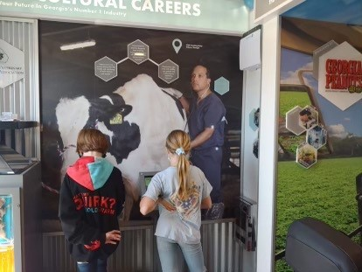

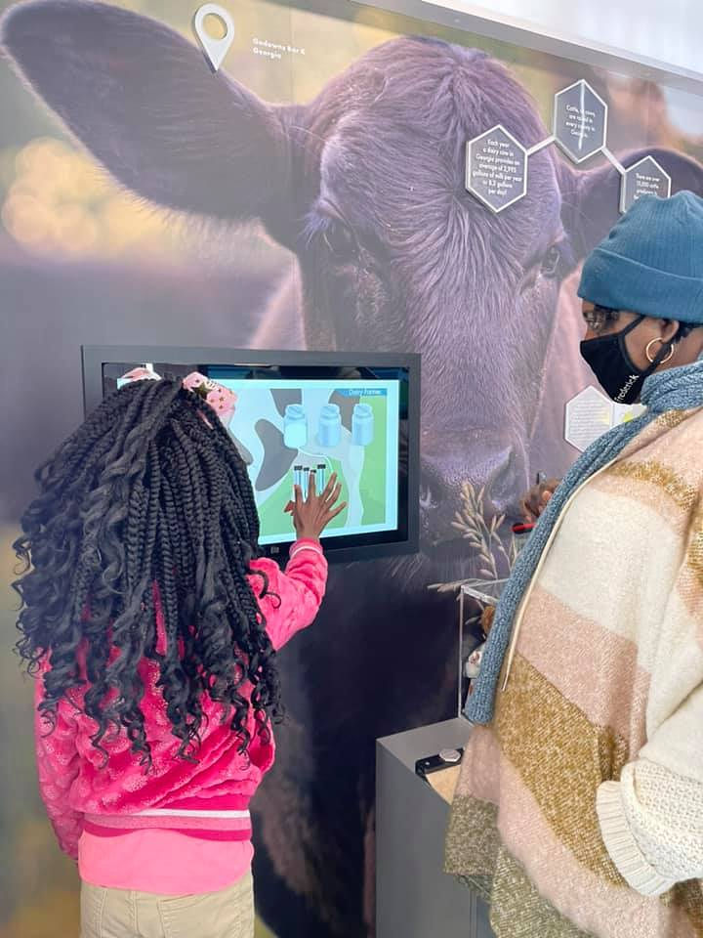

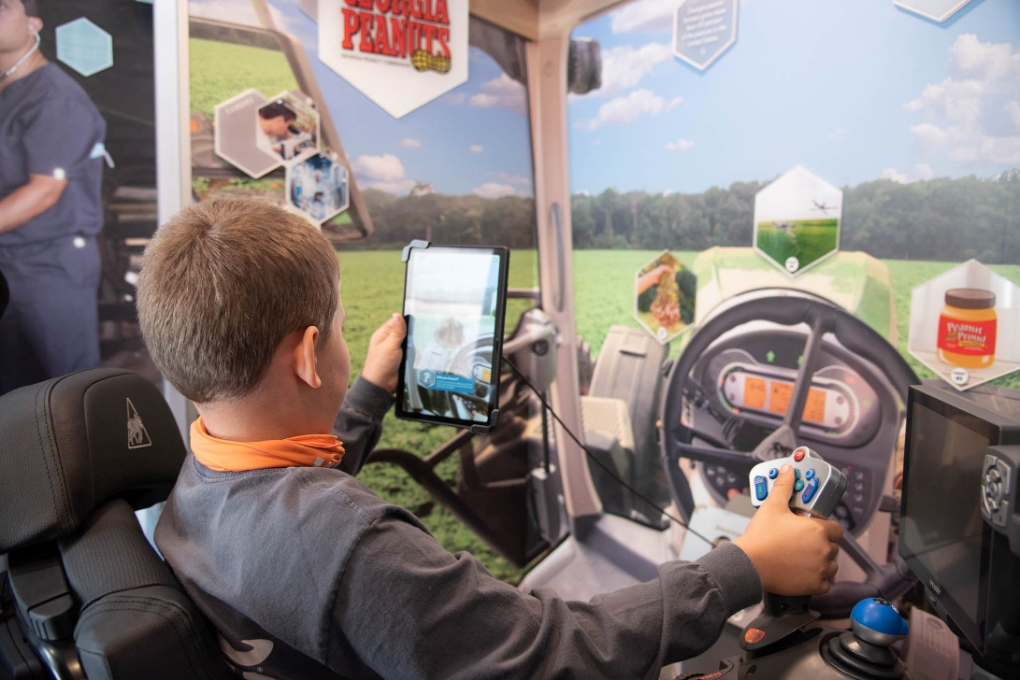

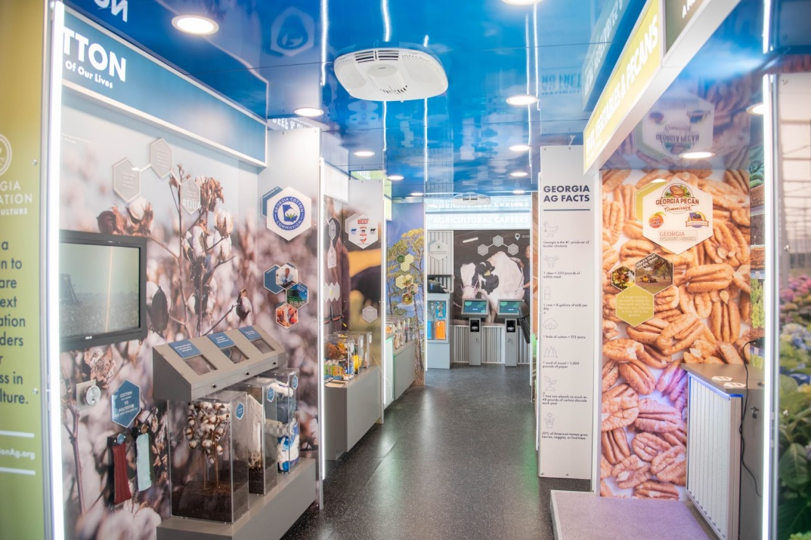

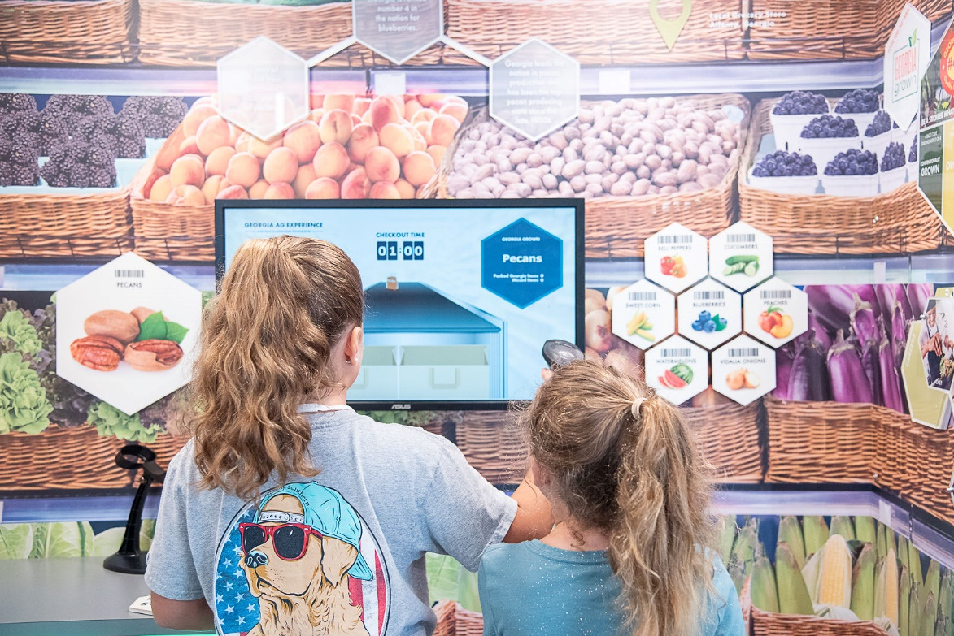
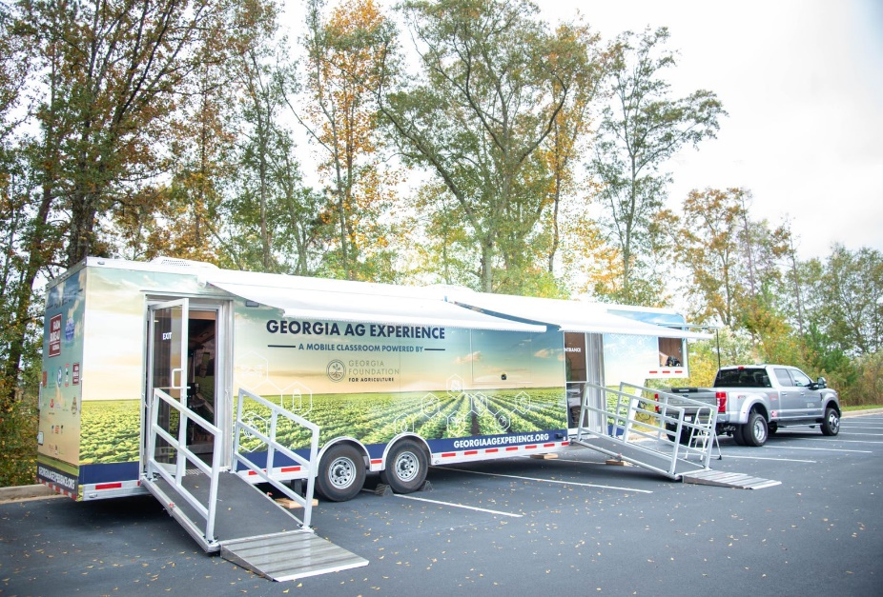

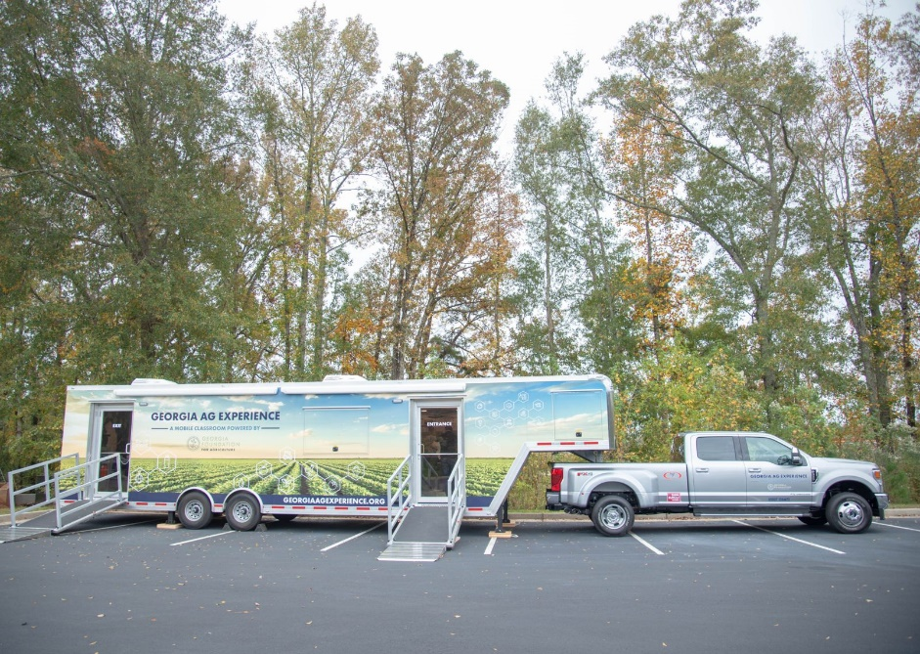

The Georgia Foundation for Agriculture is a non-profit 501(c)3 organization dedicated to preparing the next generation of leaders for success in Georgia agriculture. The GFA works with Georgia Farm Bureau and other Georgia agricultural and educational organizations to achieve its mission. The foundation offers scholarships to students pursuing agricultural careers, funds leadership development programs, and projects that increase the public’s understanding of agriculture. To make a tax-deductible donation, learn more about the foundation or the scholarships, visit www.gafoundationag.org or contact Lily Baucom at info@gafoundation.org or 478-405-3461. ###

