MEDIA ADVISORY

WHAT The Georgia Foundation for Agriculture’s Georgia Ag Experience mobile classroom will visit NAME OF THE SCHOOL OR ORGANIZATION on DAY OF WEEK, MONTH & DATE (i.e. Wednesday, Jan. 6 Write # only! Don’t add th, st or rd after #). The Georgia Ag Experience will be at the school MONTH & 2 DATES (i.e. Jan. 6 & 7) but media availability is only for MONTH & DATE (i.e. Jan. 6 – day that GAE program assistant & parties involved in GAE visit agree on) from time range set for media availability (i.e. 11 a.m. to 2 p.m.)

The Georgia Ag Experience is a 36-foot trailer equipped with colorful farm photos, interactive technology and displays of products made from various ag commodities Georgia farmers grow. The mobile classroom is designed to give third through fifth-grade students and the public a chance to learn more about the commodities that are located throughout the state of Georgia that impact their everyday lives.

The Georgia Ag Experience gives students an opportunity to experience agriculture in ways that they may have not have had the opportunity to take part in. Students will learn how farmers plant and harvest their crops, take care of their animals and preserve the natural resources on their farms.

The classroom also includes a station highlighting the many career options in agriculture. All exhibits and lessons that are part of the Georgia Ag Experience have been professionally designed to meet science, technology, engineering and math (STEM) standards.

WHERE NAME OF SCHOOL OR ORGANIZATION
ADDRESS OF VISIT LOCATION – STREET ADDRESS
CITY, GA. ZIP CODE

EVENT Georgia Ag Experience spokespersons
CONTACTS Available for interviews: TIME PERIOD GAE SPOKESPERSONS WILL TALK TO MEDIA (i.e. 11 a.m. to 2 p.m.)

LIST Name(s) of whomever has been designated to talk to media
Name, title
Cell #
Email address

i.e.
Natalie Bennett, Georgia Foundation for Agriculture educational program assistant
Cell: 770-500-8417
Email: nabennett@georgiaagexperience.org
OR
Name of other local person, Name of your county, County Farm Bureau office manager OR Women’s Committee Chairperson or President
Cell #
Email address

Below are photos that can be ran with a press release:
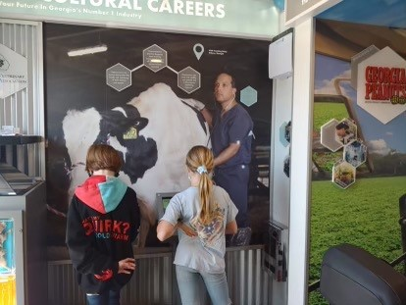
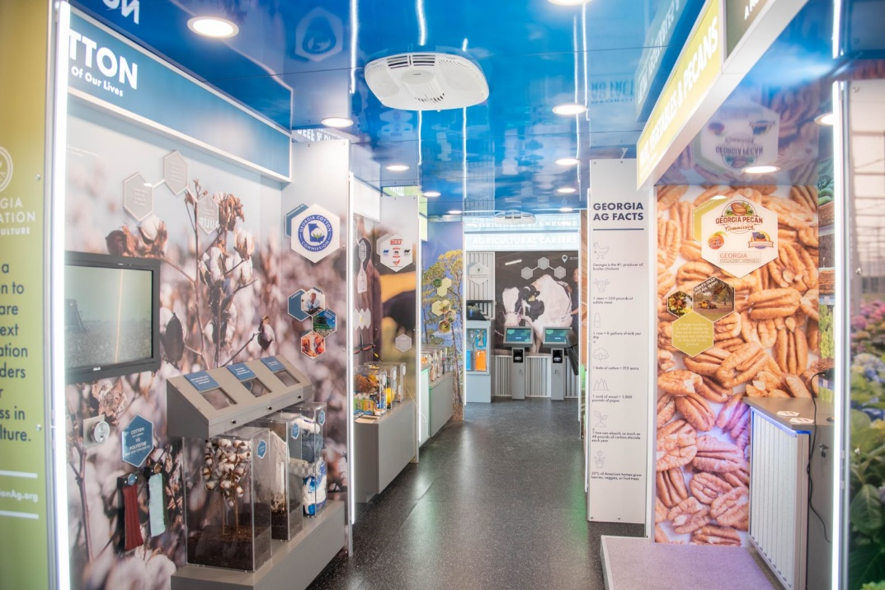
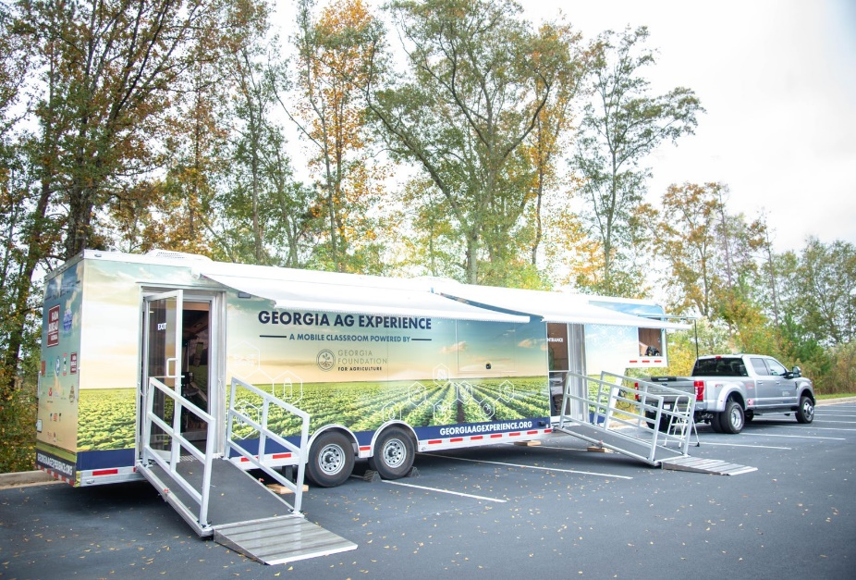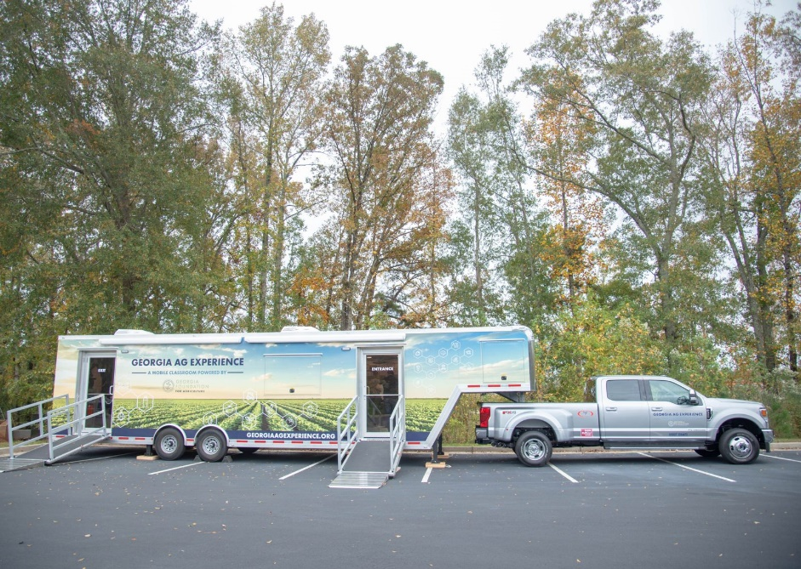

FOR IMMEDIATE RELEASE CONTACT: Lily Baucom
January 5, 2021 Office: 478-405-3461
Cell: 404-803-4054
Lrbaucom@gfb.org

GEORGIA AG EXPERIENCE WILL TAKE FARMS TO SCHOOLS

MACON, Ga. - Beginning Jan. 6, 2021, the Georgia Ag Experience will begin traveling to elementary schools and ag events across Georgia to provide a virtual field trip to the farm. The Georgia Foundation for Agriculture (GFA) created the mobile classroom, which is housed in a 36-foot trailer, to give third through fifth-grade students and the public a chance to visit a poultry house, cattle pasture, stand of timber, horticulture nursery, a produce stand full of fresh Georgia fruit, vegetables and pecans, cotton and peanut fields.
Colorful farm photos, interactive technology and displays of products made from the various ag commodities highlight the importance of Georgia agriculture to our daily lives. Students will learn how farmers plant and harvest their crops, take care of their animals and preserve the natural resources on their farms. The classroom also includes a station highlighting the many career options in agriculture. All exhibits and lessons that are part of the Georgia Ag Experience have been professionally designed to meet science, technology, engineering and math (STEM) standards.
“Realizing that the majority of Georgia’s residents are more than three generations removed from living on a farm and have little to no first-hand knowledge of how farmers grow their food, cotton for clothes, or timber for paper and lumber, the Georgia Foundation for Agriculture wanted to create a mobile classroom that would give students and adults who have never visited a farm a chance to experience Georgia agriculture,” said Lily Baucom, GFA executive director. “This was an enormous undertaking for our foundation, and we are so grateful to the many sponsors who have partnered with us to make the Georgia Ag Experience a reality.”
The Georgia Ag Experience will begin its school visits in South and Middle Georgia from January 6 through May 2021. The travel schedule for January through March has been set.
The Georgia Foundation for Agriculture is partnering with county Farm Bureau offices across the state to arrange local mobile classroom visits. Only county Farm Bureau staff can book classroom visits with the foundation.
Teachers, school staff or community leaders interested in booking the Georgia Ag Experience for a school or community event should visit www.gfb.ag/experienceplanavisit to access instructions for scheduling a visit and a list of dates the mobile classroom will be available across the state in 2021 from April to the end of the year.
Anyone interested in working with their county Farm Bureaus to bring the Georgia Ag Experience to their school or community should first contact their local Farm Bureau office. Visit www.gfb.ag/contact to access your local Farm Bureau’s contact information.
For more information about the Georgia Ag Experience and a list of the ag organizations, agribusinesses and Georgia commodity commissions that are generously supporting the mobile ag classroom visit www.georgiaagexperience.org. Visit www.gfb.ag/GAEclassroomvirtualtour to tour the classroom.
###

ABOUT THE GEORGIA FOUNDATION FOR AGRICULTURE
The Georgia Foundation for Agriculture is a non-profit 501(c)3 organization dedicated to preparing the next generation of leaders for success in Georgia agriculture. The GFA works with Georgia Farm Bureau and other Georgia agricultural and educational organizations to achieve its mission. The foundation offers scholarships to students pursuing agricultural careers, funds leadership development programs and projects that increase the public’s understanding of agriculture. To make a tax-deductible donation, learn more about the foundation or the scholarships, visit www.gafoundationag.org or contact Lily Baucom at info@gafoundation.org or 478-405-3461.

